Now Offering
Tibetan Medicinal Foot Soaks

Featuring high quality, pharmaceutical grade herbs from Tibet & China. Direct from the farms to the clinic.

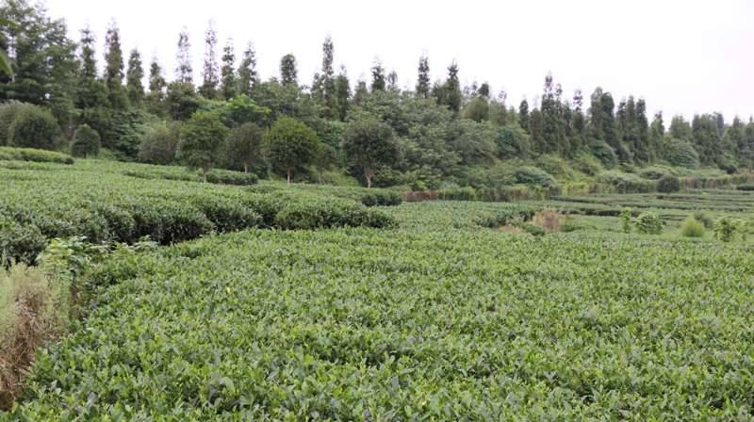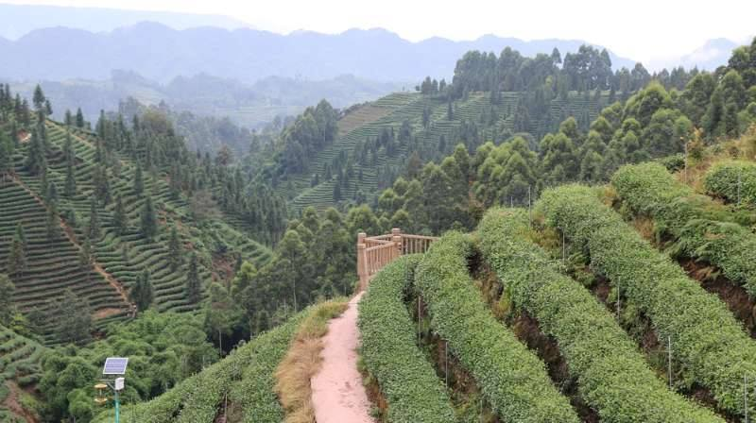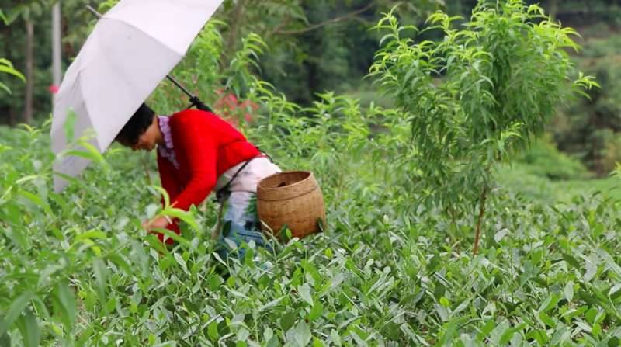

Common Conditions Treated:

Peripheral Neuropathy
Diabetic Neuropathy
Plantar Fasciitis
Cold Hands & Feet
Inflammation/Pain
Arthritis Pain
Headaches
Fertility
Menstrual Issues
Digestive Issues

How the Foot Soaks Work

The herbs in this formula act syndergistically to improve blood circulation. The actions and temperature of the herbs will help the heart to pump – similar to the effects of going for a walk or exercising. This increase in circulation will help bring fresh blood to injured areas. The herbs are absorbed trans-dermally through the skin of the feet and act first to dilate the vessels in the leg and improve circulation. As we know, good circulation in the legs is very important. The beneficial effects travel up from there.

Overall Effects

- Helps person get mobile again b/c mobility is key to get rid of chronic pain
- Get longer periods of movement w/o pain and fatigue
- Indirectly has detoxification effects
- increased blood circulation to feet—like shaking a snow globe—body becomes aware of oxidative damage that may have been cut off from rest of body
- signals macrophages to begin eating dead tissue --may get increase in pain at this stage –
- cleans out dead tissue- as these tissues get re-introduced to the body on their way out, it may increase pain signal for a couple of days—depends on the person
- may get itching- (inflammatory response) around feet-similar to itching as a wound heals; tissue is being rebuilt as well
- these are great signals for prognosis

Herbs are responsibly wild crafted- Ecology of the region is being protected , culture of regions is protected/respected. Proceeds go to helping provide educational resources, shoes, helping disabled children in the community.

Contraindications

Not for patients with metastatic cancers
Not for pregnant women
Do not take if you have a cold or flu
Do not use if there are open sores, burns or wounds on your feet or legs.

Avoid soaking while under a draft or air conditioning fan, while hungry expecially with a history of low blood sugar crashes.
Not appropriate for children except under advisement of a practitioner.

Recommended soaking tub:
Easiest is Any Foot Spa with Heat that is able to maintain the desired temperature needed.
You can use a non-electric tub or dishpan, but you have to continually add hot water to maintain the temperature and wrap a towel around the tub and your legs to keep the heat in.

