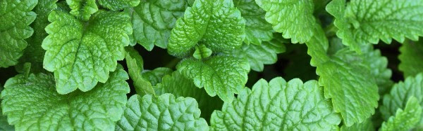
ENLIGHTEN Tea

Many of you have seen the ‘gold brick’ packages in the office. I’m thrilled and fortunate to be able to offer you all this wonderful, carefully sourced and rather exclusive blend of the popular and highly beneficial formula Xiao Yao San in this tea format. My affiliation with a consortium of practitioners here in the states and in China has allowed me to get this tea along with the Tibetan Medicinal Footsoaks for my patients. Part of what makes these formulas so powerful is that they are not only sourced and sorted for their quality, they are harvested sustainably as well as at the proper times and conditions to maximize potency. As a result, there will be periods of time when I will not have any in stock. We do not get these formulas unless they are perfect.

How Does It Work?
Enlighten Tea regulates the stress chemical cortisol in the body. It does this by helping the liver to break down excessive levels cortisol from the nervous system. It has been shown to be highly effective for hormone regulation, calming digestive tension, and easing mood issues such as stress, depression, anxiety, insomnia, Fibromyalgia, PMS, ADD, PTSD, sleep disorders and a host of other afflictions.

Suggested use.
Honestly, this is the kind of tea someone can drink on a daily basis until they feel better. Many patients feel immediate relief, for those with more severe symptoms it can take up to 2 weeks (think heavy fibromyalgia). So practitioners typically prescribe a 30 day supply and then assess from there.
Some patients can start on one bag others need 2-3/day. Some patients like to just keep a box on hand when they have symptoms - others will want to stay on it daily for up to a year.

Taste.
The master herbalist who has been practicing Chinese Medicine for over 50 years insisted on making it taste incredibly good. People generally describe it as sweet, earthy and bold. I, personally, think it tastes minty, gingery, and rich.

How to prepare.
As with most herbal formulas like this, there is a specific way to prepare it to maximize the potency and benefits. Remember, this isn’t green tea. Because the tea contains roots, it needs high heat and a good amount of steeping time to fully “wake up” the herbs to extract all the goodness from them.
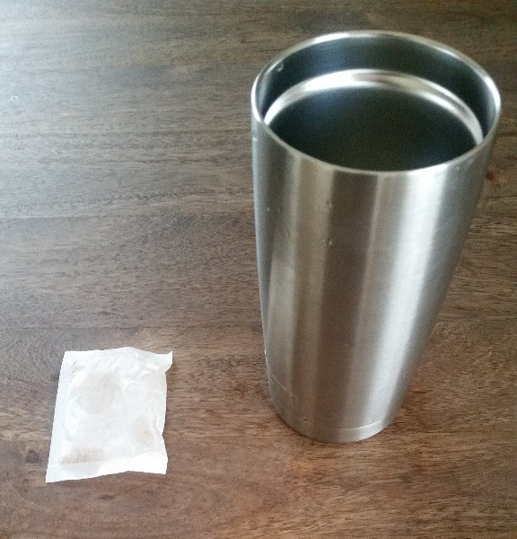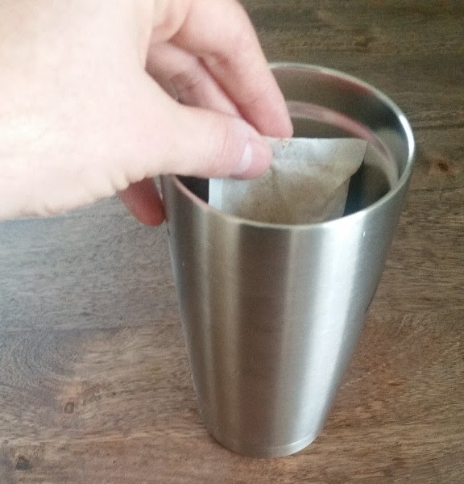
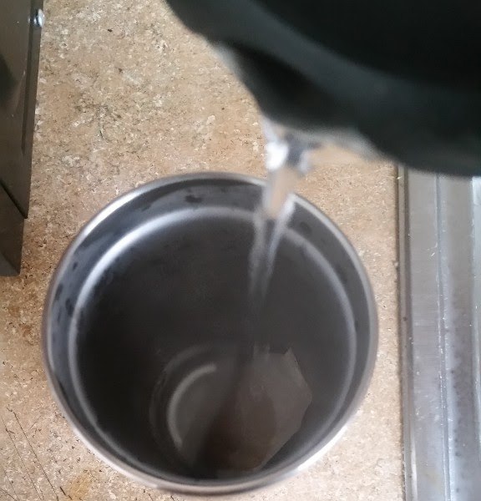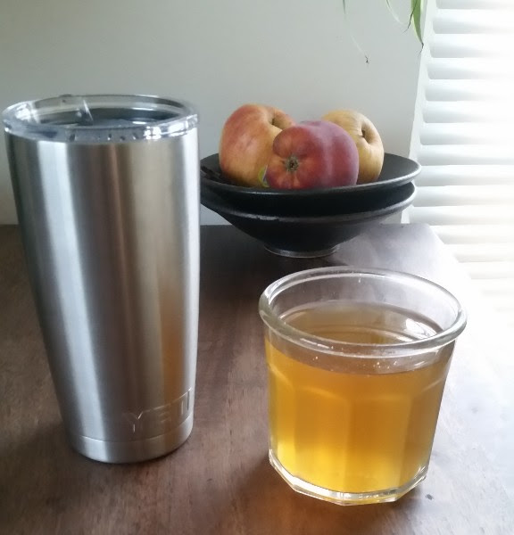

Preparation checklist.
- Put bag/s in an insulated thermos.
- Boil water to 90 degrees celsius. (~8 oz for 1 bag, ~12 oz for 2 bags, ~18 oz for 3 bags)
- Pour the boiling water into the thermos.
- Put the lid on the thermos and let it steep for 20 minutes.
- Start to sip. Some people pour the tea out of the thermos into a mug so it cools to drinkable temperatures.
- You should then rebrew the same bag/s with new boiling water. Just repeat the instructions above up to 2 more times.
- The first brew isn’t the most potent, it’s mostly rehydrating the roots. Most beneficial pours are 2 & 3.
- Tea is good for up to 12 hours after the first steep.
- Don't rebrew a bag that has been left out overnight. It’s really bioactive, your body loves it, but so does mold.
*Side note: Feel free to add a tea bag of mint. You can get it at the grocery store and add to the thermos when brewing to "cool" down the formula if needed.

